Sakshi Dhamapurkar PRN:21510073
//Experiment 1 Program based on structures and pointers in C
#include<stdio.h>
struct data
{

int roll_no;
char stuname[20];
float mark;
}s[5];

int main()
{
for(int i=0;i<5;i++)
{ printf("ENTER INFORMATION OF %d STUDENT",(i+1));
scanf("%d",&s[i].roll_no);
scanf("%s",s[i].stuname);
scanf("%f",&s[i].mark);
}
for(int i=0;i<5;i++)
{ printf("INFORMATION OF %d STUDENT\n",(i+1));
printf("ROLL NO.=%d\n",s[i].roll_no);
printf("NAME OF STUDENT=%s\n",s[i].stuname);
printf("MARK OF STUDENT=%.2f\n",s[i].mark);
}

}
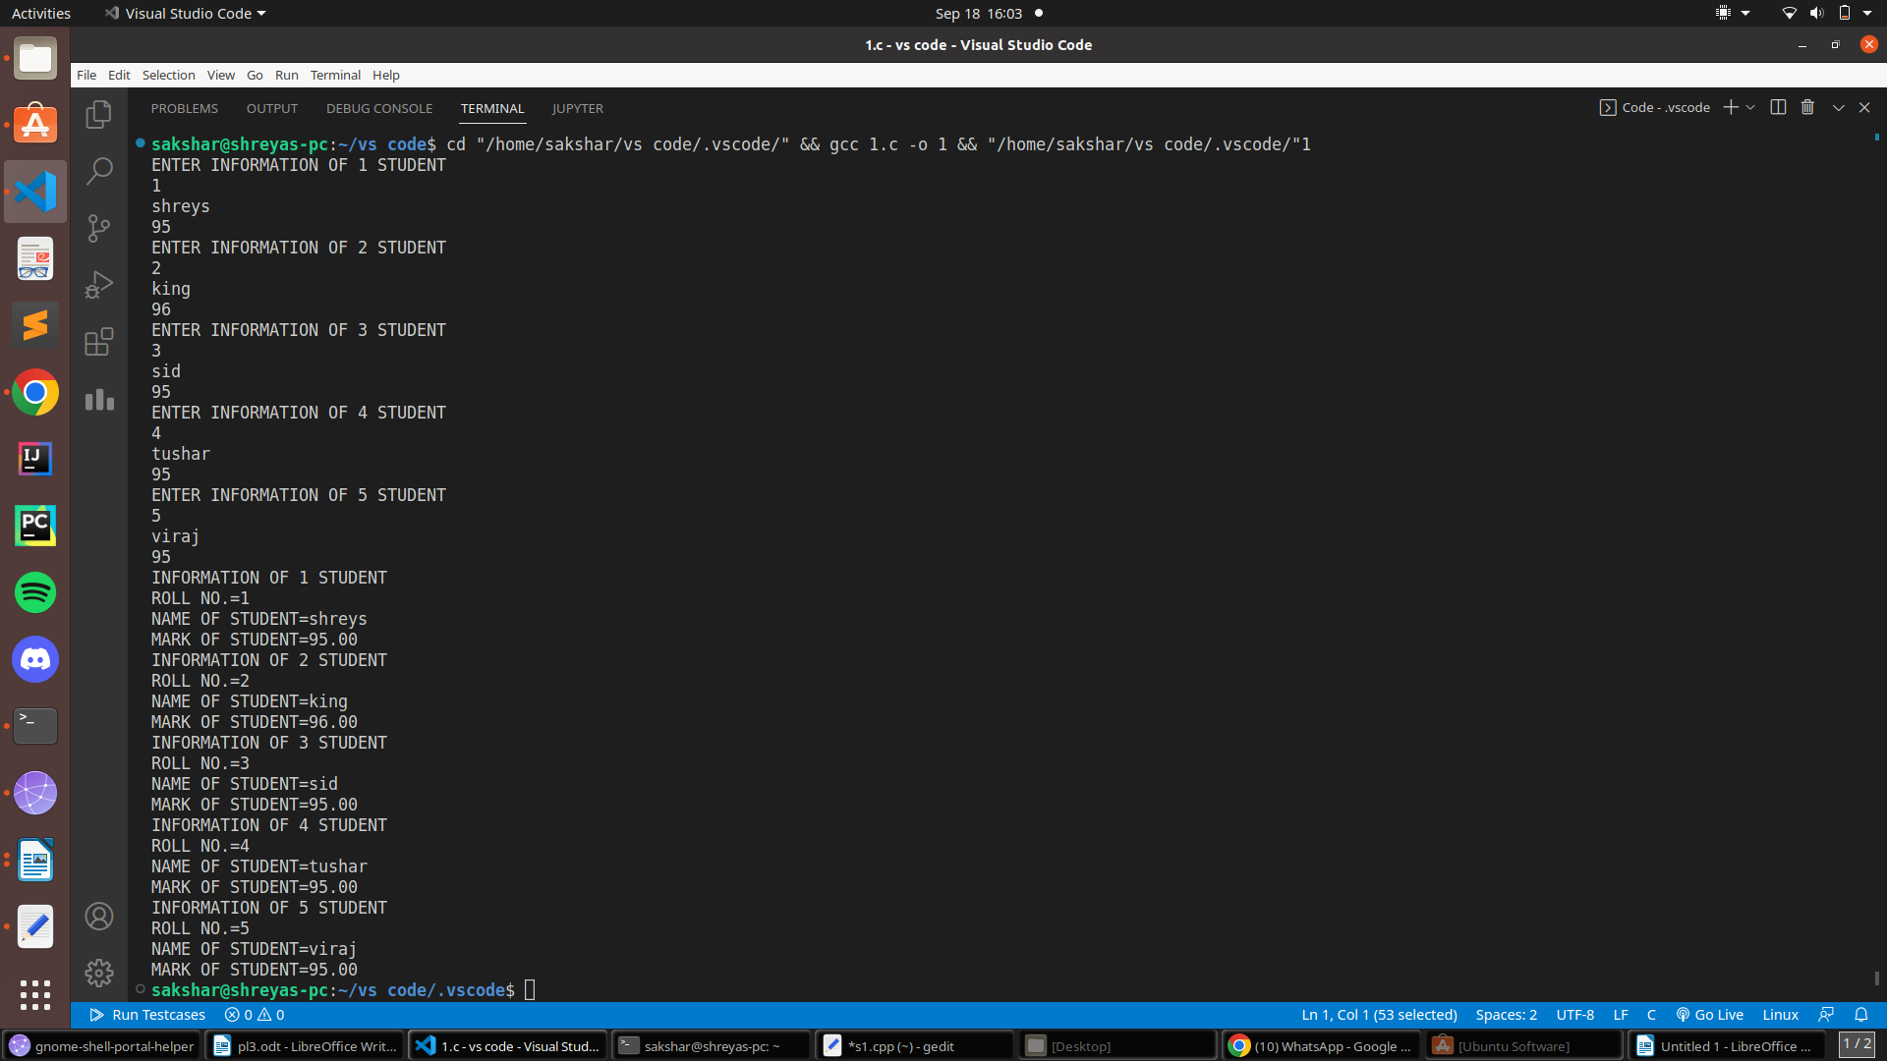
OUTPUT :

// POINTER EXAMPLE //
#include<stdio.h>
void swap(int *x,int *y)
{
int t;
t=*x;
*x=*y;
*y=t;
}
int main(){
int x;
int y;
scanf("%d",&x);
scanf("%d",&y);
swap(&x,&y);
printf("%d %d",x,y);
}
OUTPUT:
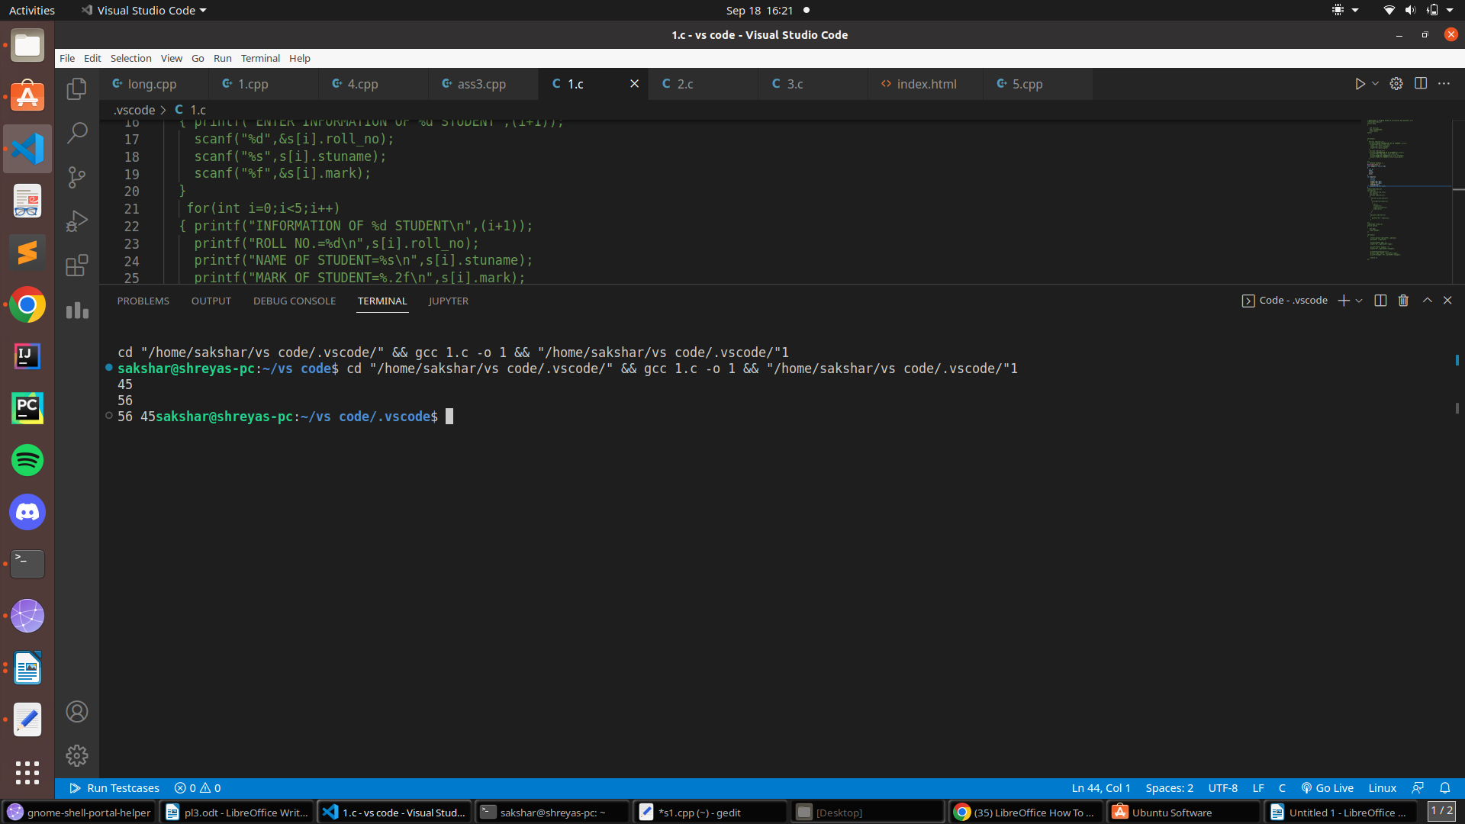

// pointer array example //
#include<stdio.h>
int main(){
int a[5]={4,5,8,1,2};
int *ptr=a;
for(int i=0;i<5;i++)
{
for(int j=i+1;j<5;j++)
{
if(*(ptr+j)<*(ptr+i))
{
int t;
t=*(ptr+i);
*(ptr+i)=*(ptr+j);
*(ptr+j)=t;
}
}
}
for(int i=0;i<5;i++)
{
printf("%d ",*(ptr+i));
}

}
OUTPUT:

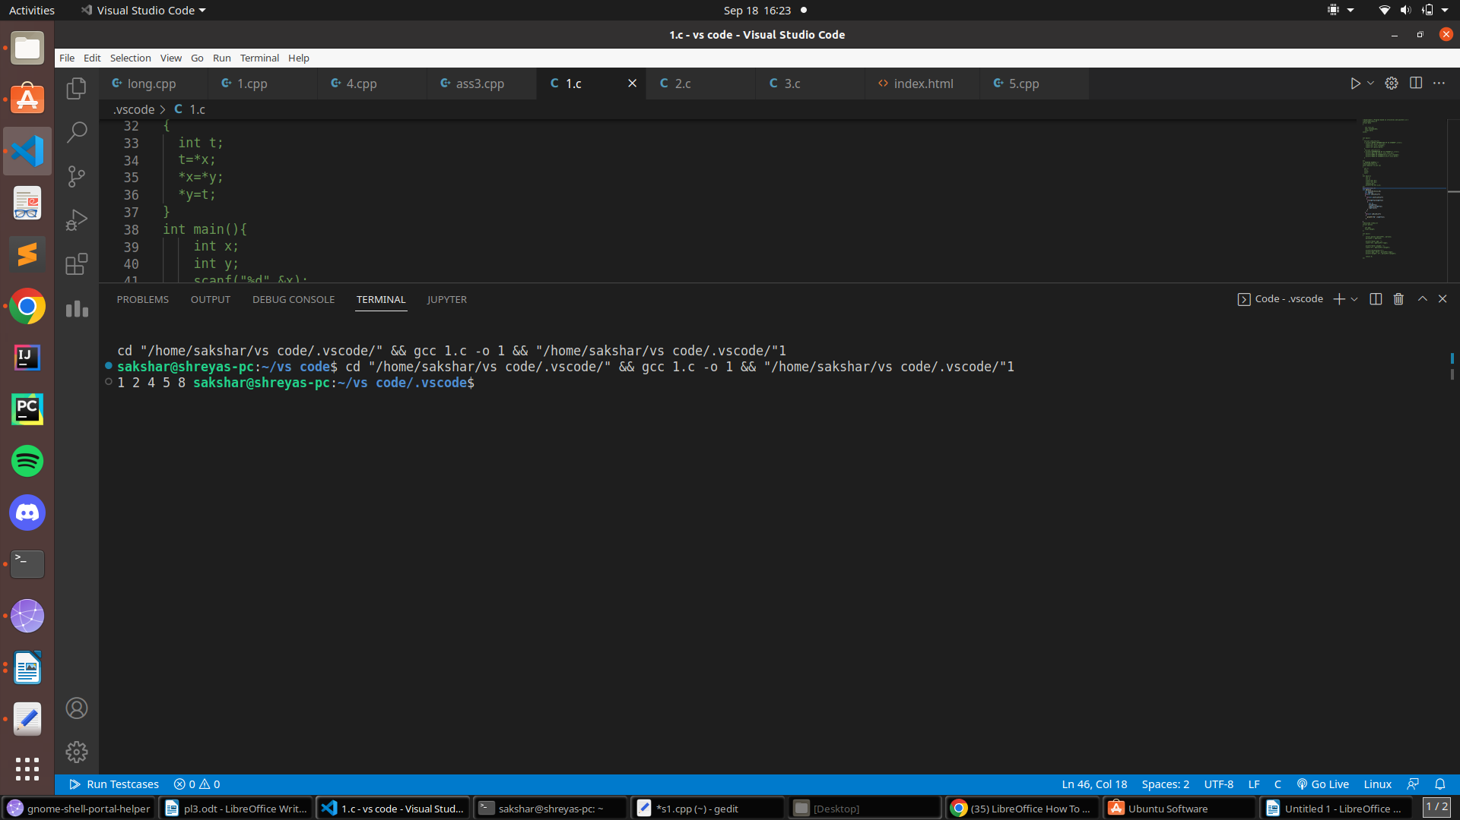
// POINTER STRUCTURE EXAMPLE
#include <stdio.h>
struct person
{
int age;
float weight;
};

int main()
{
struct person *personPtr, person1;
personPtr = &person1;

printf("Enter age: ");
scanf("%d", &personPtr->age);

printf("Enter weight: ");
scanf("%f", &personPtr->weight);

printf("Displaying:\n");
printf("Age: %d\n", personPtr->age);
printf("weight: %f", personPtr->weight);

return 0;
}
OUTPUT:

